**PACK Expo Summary**

**Nathan LeRoy**

**October 23rd, 2018**

**ABE 557**

My group’s senior design project is on the production of probiotics in an oral dosage form. We have not yet decided what form, but the top two choices are tablet’s or gelatin capsules. My goal at the PACK expo was to talk to some companies that had a foot in either area of dosage form development and production. Although the pack expo was highly specific towards the packing and containing of food items, I was able to find some information and speak to some reps about the mass production of oral dosage forms and their development as a unit operation. In addition, I had some good talks with reps about powder flow and its importance in these unit operations.

Fette is a tablet compression company. They offer solutions to pharmaceutical companies which provide them with the resources to turn their API and excipient blend into an oral dosage form. The rep I talked to started up the machine for us and gave us a demonstration of the unit op in action. The machine, in short, takes in powder, fills a die with a motorized hopper, and then the machine uses large rollers to punch a press and create a small tablet. The machine is capable pressing and API-excipient blend desired, and it is up to the manufacturer of the drug to decide whether it is suitable for pressing. The machine can produce upwards of 106 tablets per day.

Another company, Volkmann, was able to provide me with some insight into a very important aspect of dosage for development: powder flow. They use vacuum manifolds to create pressure differentials which “suck” a powder through a series of tubing that can transport your product around to various unit ops. My literature review goes in depth on the considerations for powder flow, but this company provided me with a pamphlet and a lot of information on various practical choices for powder flow machinery. This can be an often-overlooked aspect of the process flow, but is essential for designing an efficient and reliable process.

Overall, the PACK expo was a really fun experience. It was interesting to talk to industry leaders in the packaging sector. The technology was advanced, and the flexibility of the machines used to conduct the packaging was impressive. One of my favorite parts was the Virtual Reality Set-Up from Clemson University. They had a virtual grocery store that one could walk around in and take items. Afterward, they could analyze the data of where you looked, and how long you looked at each item. This was then used to make informed decisions on how to set up and lay out grocery stores. This is something that I had never thought about before and was very interesting. I would give the experience a 7/10. I feel that if my unit operation was more properly represented, I would have gotten a lot more information, and it would have been more useful. Otherwise it was a great experience.

*Attached on the next page is a picture of me at the EXPO with some representatives from GEA and a scanning of the signed business card I received from the representative at Fette.*

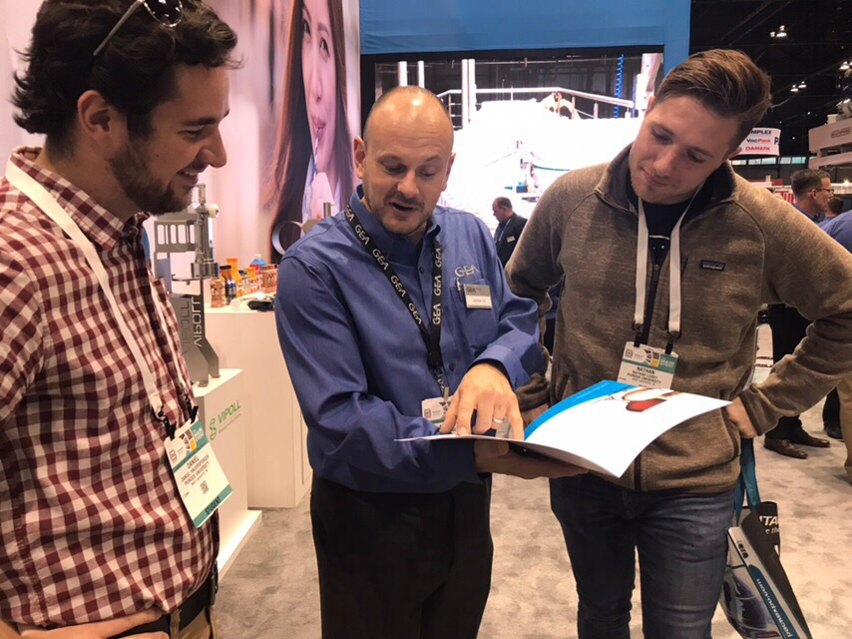

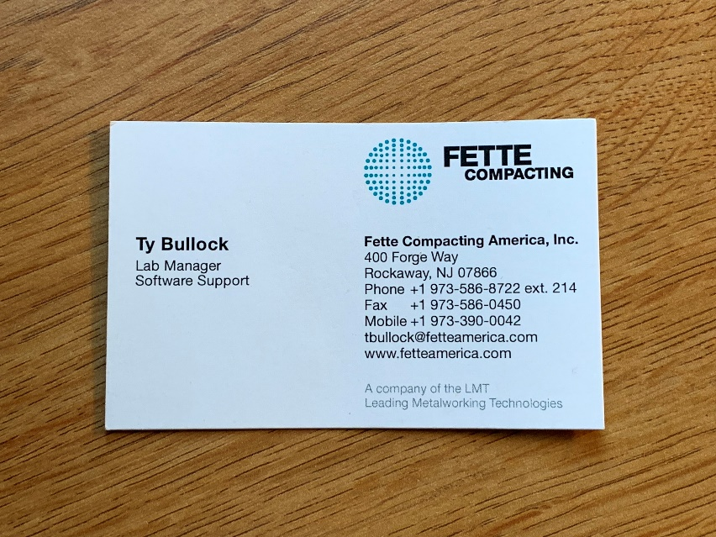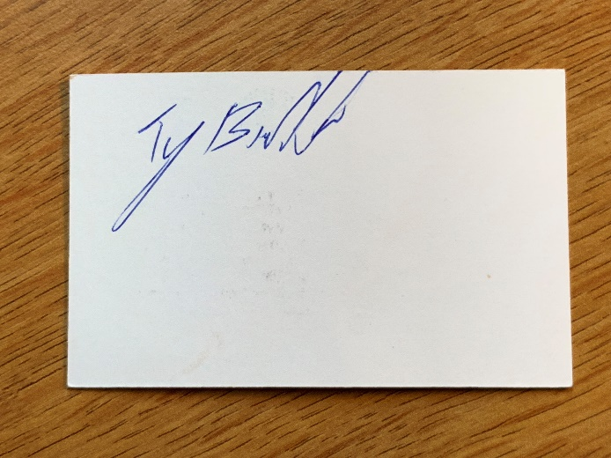

Pertinent Vendors:

1. Fette
2. Volkmann